Training Session – Factory Assessment

Factory Assessment 2

Access from Team Space 2

Create Factory Assessment Objects 3

Factory Assessment Creation from the Team Space 3

Factory Assessment Form 4

General Tab: 4

Identification Section: 4

Details Section: 5

Safety and Environmental Qualitative Evaluation 6

Save/Apply Factory Assessment form 6

Summary Check List Score Tab: 6

Summary Check List Score Section 6

Factory Assessment Action Register Section: 10

Attachment Tab: 11

Manual Action Creation: 12

Factory Assessment Import Data: 13

# Factory Assessment

The Factory Assessment is an audit visit (usually lasting 2 days) at Factories of the Main Suppliers or Sub-Suppliers: The aim is to evaluate some areas of analysis while providing a factory score.

All the FA will be created over a DUMMY project.

## Access from Team Space

The Team Space module can be opened from the homepage Application Menu.

From the Team Space menu, select the “factory assessment” process.

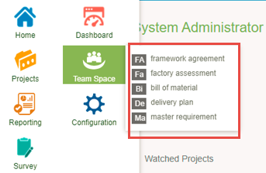

Here you can visualize the list of all Factory Assessment objects in PO and group/filter them with the appropriate parameters.

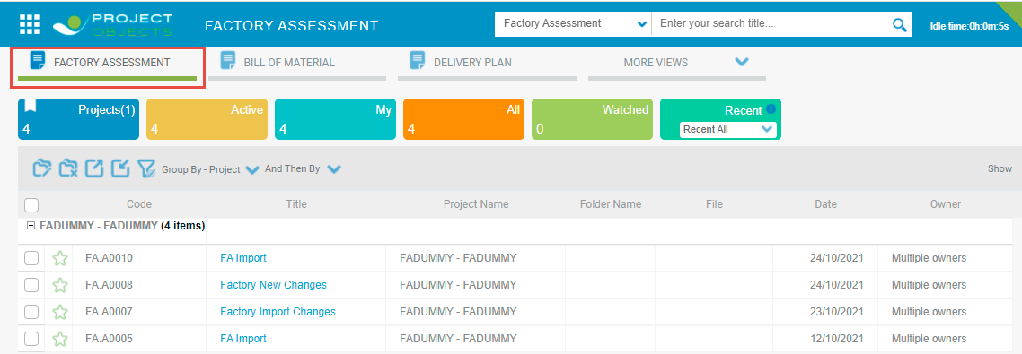

# Create Factory Assessment Objects

## Factory Assessment Creation from the Team Space

Users can create factory assessment objects from the team space “**Create New**”  icon. A create a new icon is available at the bottom left of the page.

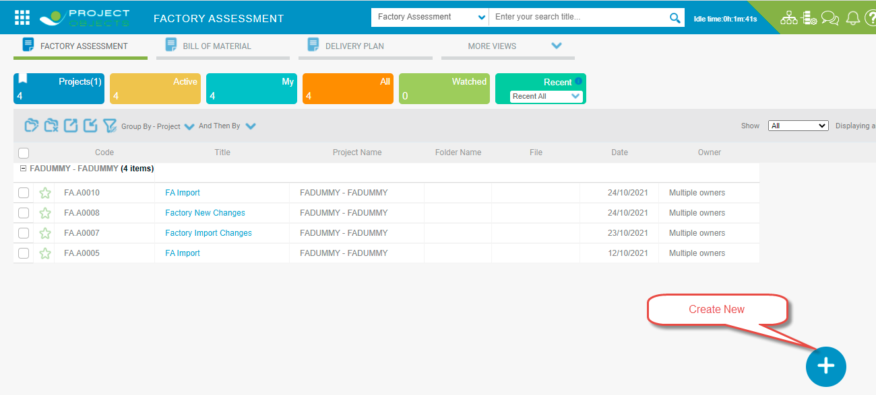

When a user clicks on the create a new icon, the factory assessment form will be open with all the relevant fields and the user has to fill in the data and save the form. After saving the form, the factory assessment object will be visible in the Factory Assessment register of the team space module.



By default, factory assessment objects will be created in the Dummy Project only.

User can also create factory assessment object in the other projects but as per the standard functionality, Factory assessment objects will be created in the Dummy Project.

# Factory Assessment Form

The factory assessment form contains three tabs: **General**, **Summary Check List Score**, and **Attachment**. With on click of the “create new” icon, the factory assessment form will be open.

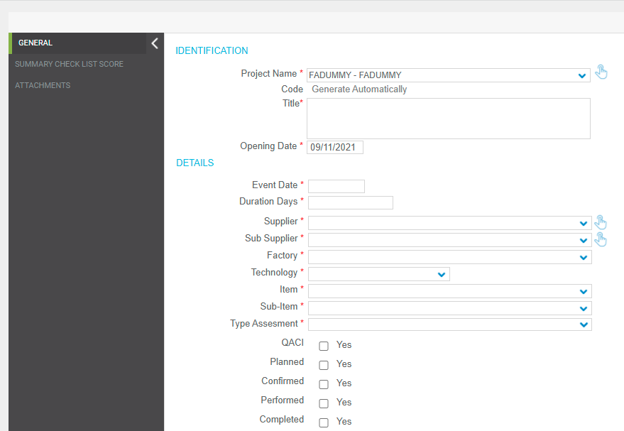

In the following paragraphs, factory assessment form details are provided:

## General Tab:

## Identification Section:

In the **Project Name** field, the FA Dummy project is selected by default, users can change it if required. **Code** will be generated automatically, **Title** will be entered manually by the user and the **Opening Date** field shows the date of creation of an object.

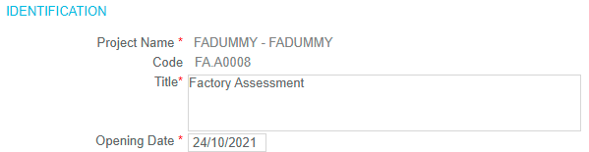

## Details Section:

**The Event Date, Duration** fields are manual entry fields. **Supplier** and **Sub Supplier** fields will show the list of all the suppliers available in the system. On the selection of Supplier, sub-supplier and **Factory** data will be retrieved. If a user changes the sub-supplier data then factory data will be changed accordingly. The **Technology** field is a drop-down field that shows all the technologies available in the system. **Item** and **Sub Items** fields are drop-down fields and data will be filtered in Item and Sub Item drop-down as per the technology selected. **Type of Assessment** is a drop-down field and the user has to select values from the available values in the drop-down.

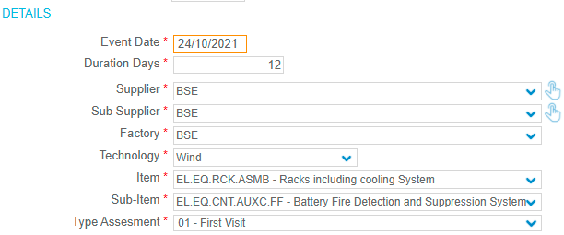

**QACI** is a check box, users can check or uncheck this field as per the requirement.



**Planned, Confirmed, Performed**, and **Completed** fields are checkboxes, and users can check these fields sequentially only. Once these fields are marked as checked then the user cannot uncheck these fields.

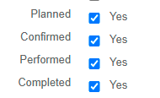

**Expediter** and **Inspection Body** fields are drop-down fields. Expediter fields show the list of users and the Inspection body field is showing the list of Suppliers. Add button is also available with these fields a user can add more than one expediter and inspection body as per the requirement.

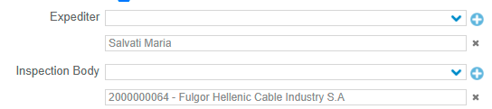

**Production Verified Capacity MW, Takt Time, Bottle Neck, Note** fields are manual entry fields and the user has to enter data in these fields manually.

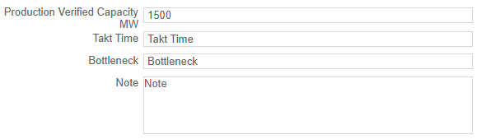

## Safety and Environmental Qualitative Evaluation

**Safety** and **Environmental** fields are drop-down fields and the user has to select values manually from the list of available values.

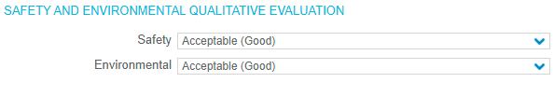

|  |  |
| --- | --- |
|  | Note that for any field, if you see a red star in front of it, it means the field requires to be filled in |

## Save/Apply Factory Assessment form

  button, in the upper-right corner of the form, your object will be added to the grid.

Clicking on the Save icon will Save and Close your object while clicking on the "Apply" icon will Save your object, but it remains open.

## Summary Check List Score Tab:

## Summary Check List Score Section

In this section, we have two grids, one for the factory assessment score and the second for the graph.

In the first grid of factory assessment scores we have 5 reports:

1. Production Readiness.
2. Sub-Supplier Management
3. Production Capacity
4. Logistics
5. Risk Management

For each report, a user has to click on the individual report, on the click of a report a pop-up will open with all the questions related to the particular report. See the below screenshot.

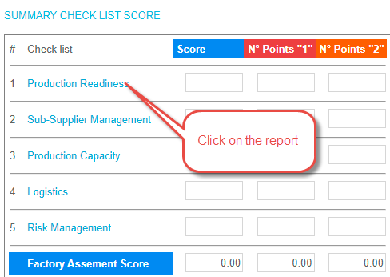

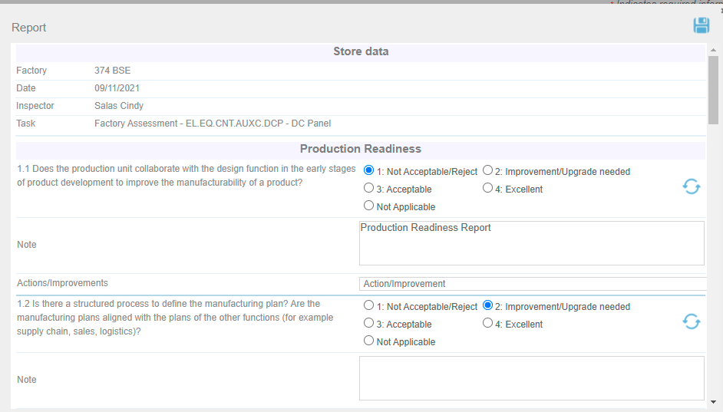

In the report pop-up, the user can see multiple questions related to a particular report and the user has to check one option from the available 5 options with the following scores:

* Not Acceptable/Reject (Score 1)
* Improvement/Upgrade needed (Score 2)
* Acceptable (Score 3)
* Excellent (Score 4)
* Not Applicable (Score 0) not counted in the total

When a user checks the scores of the available question, then the total score will be calculated in the below report pop-up. Here we have the following fields to calculate and show the total score and average score of a particular report.

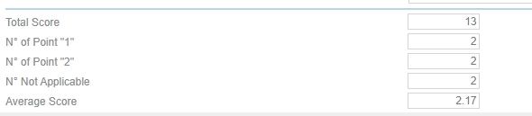

**Total Score= Sum of all selected scores**

**N° of Point "1"= Sum of the point with (Score 1)**

**N° of Point "2" = Sum of the point with (Score 2)**

**N° Not Applicable=Total count the point with (Score Not Applicable)**

**Average Score= Total Score/Total count of the questions of the section**

When the user clicks on the save icon of the report pop-up, all the details are saved in the report pop-up and the average score is updated in the grid with the particular report.

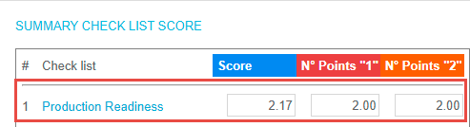

Similar to the above operation user can provide a score for all 5 available reports and after an update, the average score for all 5 reports is visible in the grid.

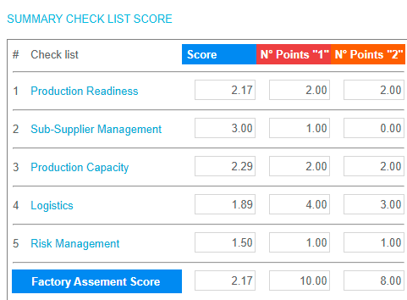

Factory assessment score is calculated as follows:

**Factory assessment score=Count of the Section Score/total count of the sections**

Factory assessment score = (2.17 + 3.00 + 2.29 + 1.89 + 1.50 )/5 = 2.17

In the report pop-up, users have also the option to put **Note, Action/Improvement,** and **Clear Score** of a question.

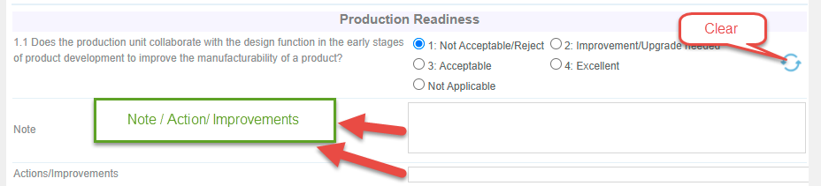

Users can also visualize the summary score by Graph available in the grid. Based on the values of reports in the grid graph is created automatically.

In the below, we are showing Attention Area and Checklist score. Attention area is visible in blue color and checklist score is visible in red color. In the below image we can see that the Sub Supplier management grid score is showing 3 and the graph is showing similar values.

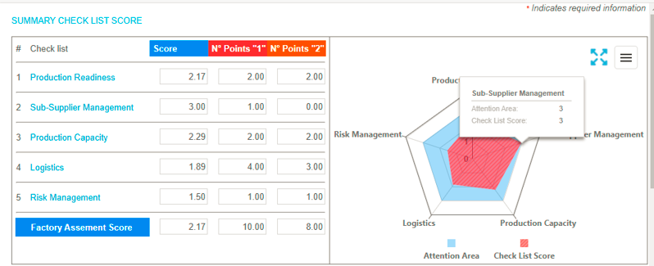

On the top right corner of the graph, the Zoom-in icon is available. Clicking on this icon, a graph is visible in zoom-in mode.

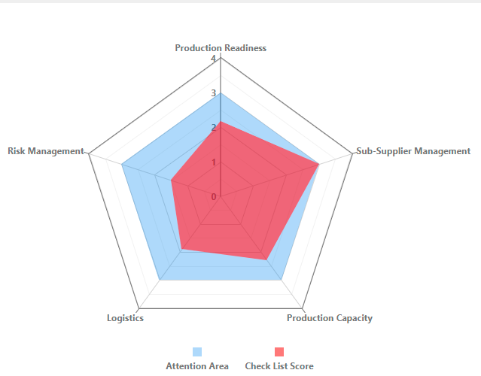

## Factory Assessment Action Register Section:

If a user saves any question with the score of 1 or 2, “Not Acceptable/Reject” or Improvement/Upgrade needed, a new action will be automatically generated & linked to the current factory assessment object. In the below image we can see that the user has saved a question with a score of 1 and a question with a score of 2.

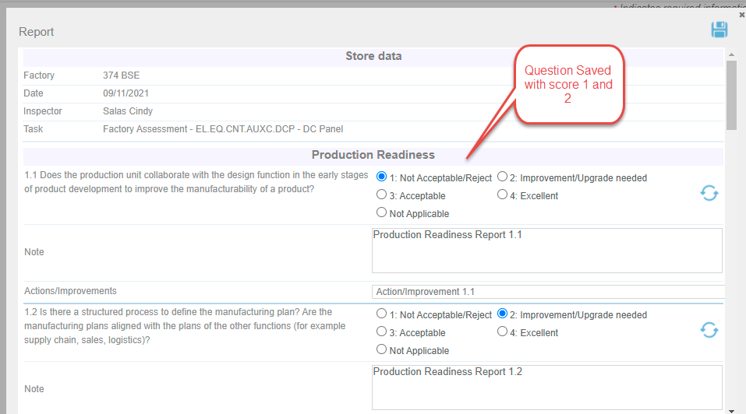

This will automatically create two actions objects with the above score and these action objects will be associated with the same factory assessment objects.

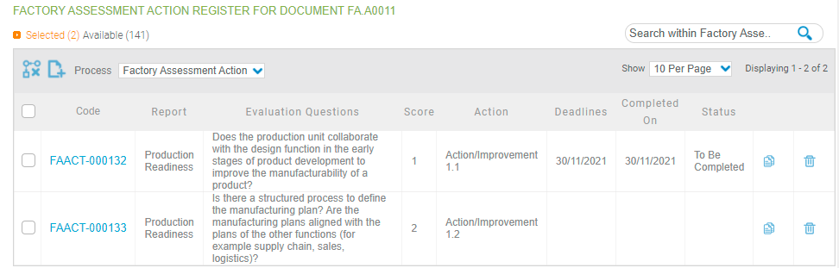

Action fields will be initialized based on the following logic:

* **Project Name**: Name of the projects in which factory assessment object is created.
* **Title**: Title of the factory assessment object.
* **Code:** Automatic action ID
* **Factory:** Factory data will be retrieved from the factory assessment objects.
* **Report**: The name of the section
* **Evaluation questions**: Is the question where the user selected 1 or 2
* **Score**: is the score selected by the user
* **Action**: is the text entered for the question by a user (field available in the new pop-up)
* **Deadline**: To be entered manually by the user in the new action
* **Status**: To be entered manually by the user in the new action

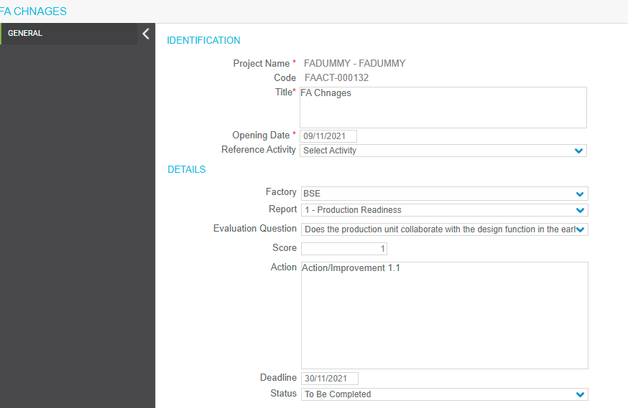

## Attachment Tab:

Users can upload any file related to factory assessment objects in the attachment control provided in the attachment tab. To upload a file user needs to click on the upload icon  on the top right corner of the attachment control. With on click of the upload icon, an upload pop-up will open.

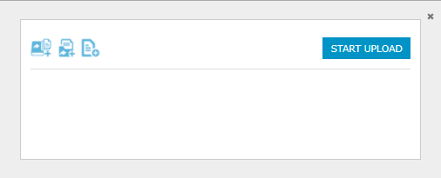

Here user needs to choose the file to be uploaded and click on the start upload button. After successful upload, uploaded files will be visible in the attachment control.

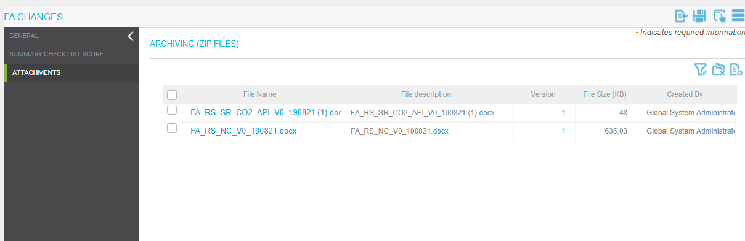

# Manual Action Creation:

Users can create a new action object manually with the icon “ New Action” available in the action register. When a user clicks on the New Action icon, an action form will open and the user has to fill in the information manually here.

* **Project Name**: Name of the projects in which factory assessment object is created.
* **Title**: The title would be the manual entry.
* **Code:** Automatic action ID
* **Factory:** Factory data will be retrieved from the factory assessment object.
* **Report**: Need to select from the available 5 reports.
* **Evaluation questions**: On the selection of the report, the evaluation question will be filtered accordingly.
* **Score:** Is the manual entry by a user.
* **Action**: This is the manual entry by a user.
* **Deadline**: To be entered manually by the user in the date field.
* **Status**: To be entered manually by the user from the available values.

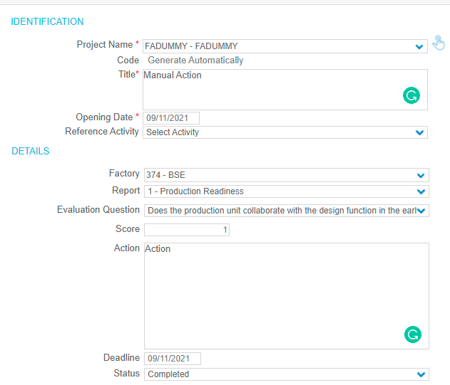

After saving the form, action objects will be created manually and visible in the action register grid.

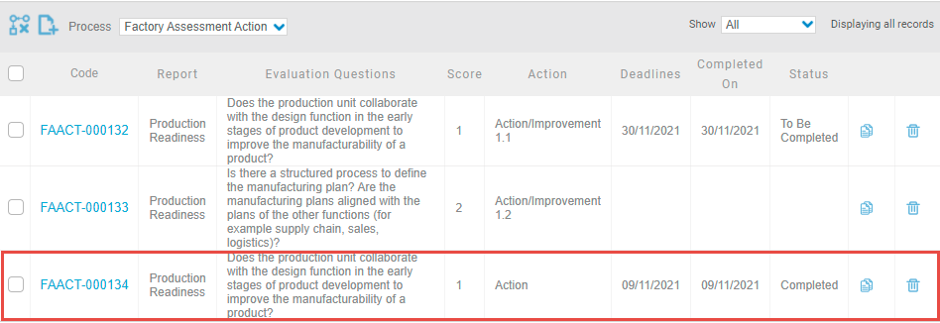

# Factory Assessment Import Data:

Users can also import the summary checklist score from the standard excel template of factory assessment. We have defined the standard template of factory assessment.

In the standard template there are 5 sheets for all 5 report sections:

1. Production Readiness.
2. Sub-Supplier Management
3. Production Capacity
4. Logistics
5. Risk Management

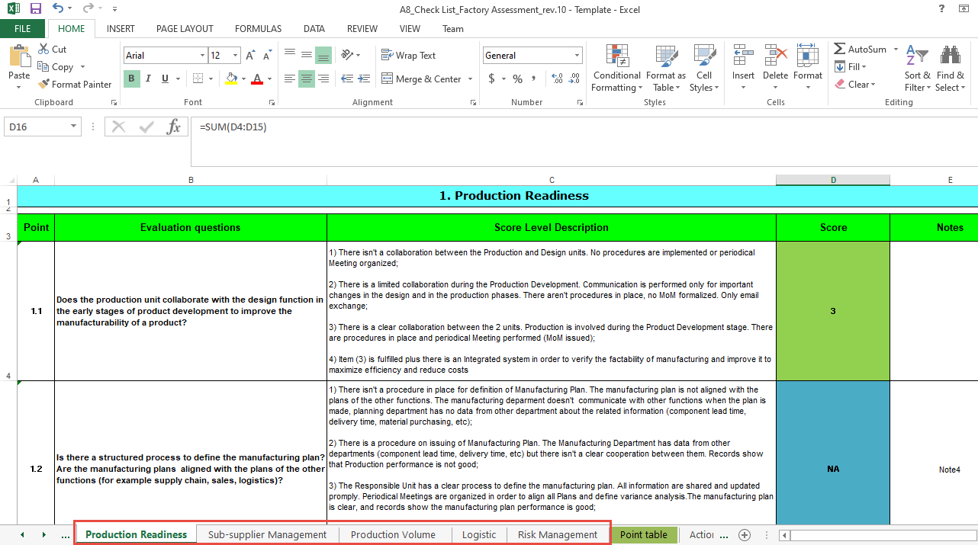

In each report section sheet, all the questions are available similar to the pop-up in the system. Adjacent to each question score is defined and the note column is defined for each question. Users need to fill sheets and questions as per the requirement and import this sheet to the factory assessment form in the system. After successful import data will be filled automatically in the question pop-up and grid. Similarly, the graph will be updated automatically and actions objects will be created automatically for the question of scores 1 and 2.

When a user fills the details in the general tab of the factory assessment form and clicks on the save/apply of the form, the import icon will appear on the top right corner of the form.

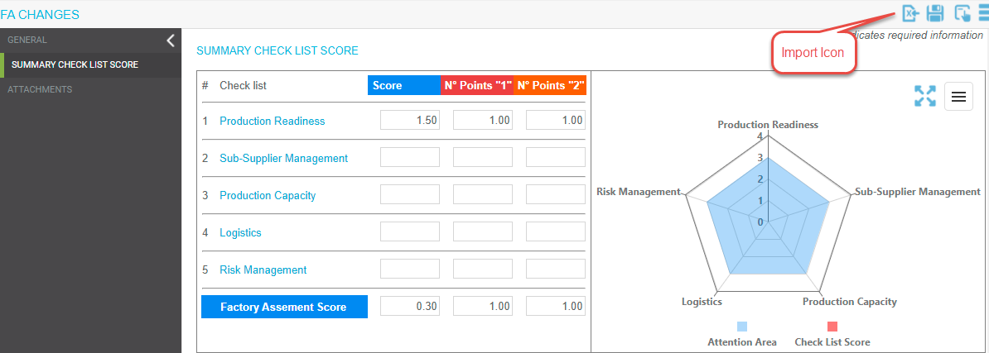

Click on the import icon, import pop-up will appear. Users need to select the template and click on the import icon.

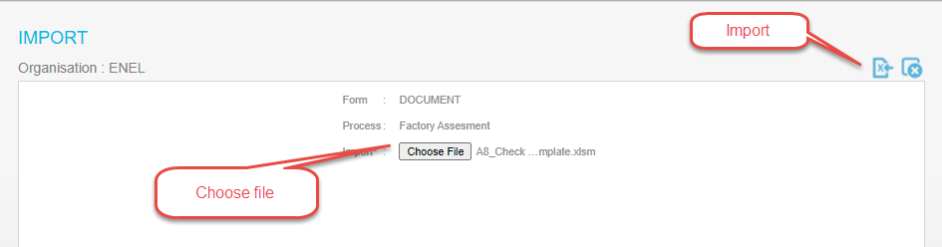

After successful import, imported data will be visible in the question pop-up and grid. Similarly, the graph will be updated automatically and actions objects will be created automatically for the question of scores 1 and 2.

